Requirements

This is a single web page that will show a users data. The userid will be passed to this page as a querystring.

The data will be from the following sources:
http://p2pool.org:9332/web/graph_data/miner_hash_rates/last_day
Another data point
http://reassent.no-ip.biz:7777/web/graph_data/miner_hash_rates/last_day

When you call the pages above, you can substitute [day] with hour, week, month, year. It dynamically provides the dataset with different interval points.

Data will also be found in a user table
User Table
-userid
-24hour_profit
-immature_balance
-unexchanged_balance
-readyforpayout_balance
-expected_btc
-datecreated (this is the date they joined)
-last_payout
-total_profits

There will also be the following database table:
user_transactions
-userid
-transaction_amount
-payment_address
-datetime
-transaction_type “payment”

The page should be similar to http://www.clevermining.com/users/167fC5tgxoUBwH4Sy3u7ezWSFBL1gRH92p

Instead of their chart controls, I would like to use the google chart controls and
the justGage controls. I will attach justgage control.

Please see the wireframe below of how the page should look like.

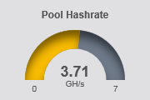
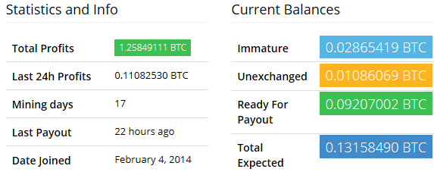

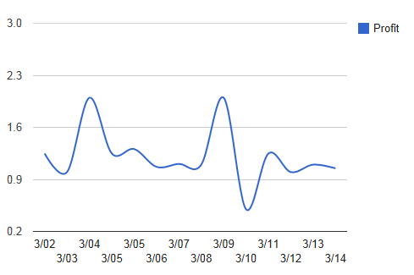
Payout

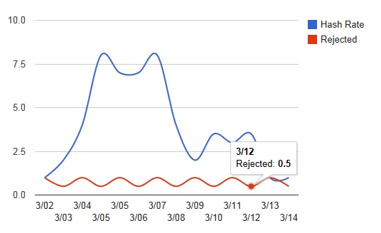

Hashrate

Both of these graphs should base their data on the selection of day, month, week, year, hour.
Chart is from http://code.google.com/apis/ajax/playground/?type=visualization#line_chart

Recent Payouts
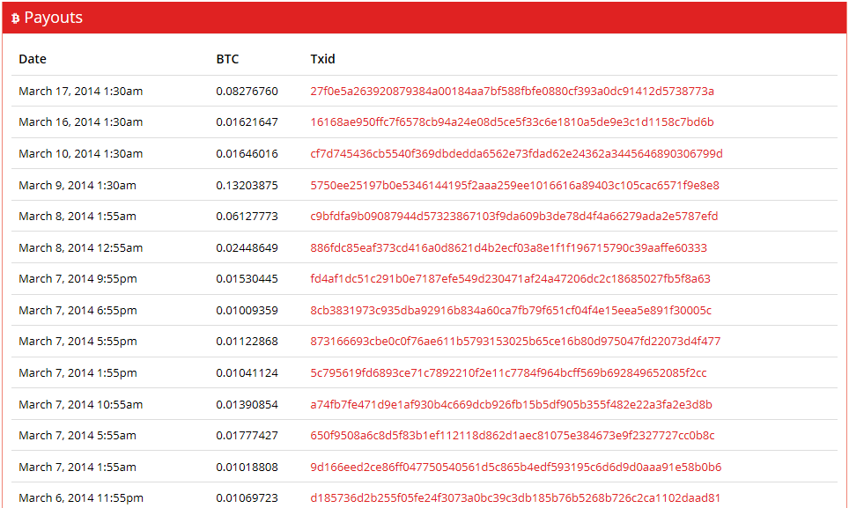

This should be based on the timeframe that the user selected above: hour, day, week, month, year.

